Smooth shading

📘 Definition
# Source: AI Source: Provided by: [Data Path: Persons Table -> ID Column: 1, Name_En Column: Motasem Essam] -> From: [ChatGPT] on [5/2/2026]
Smooth shading is a shading technique in computer graphics where light is gradually blended across a surface, making objects look smooth, curved, and realistic instead of having visible flat faces.

🌗 How smooth shading works
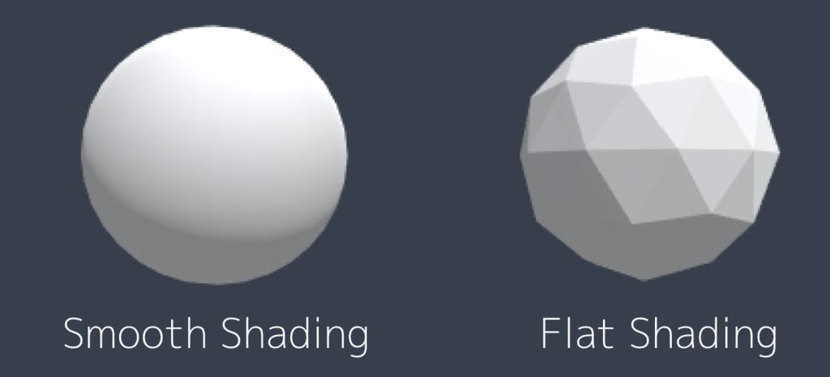
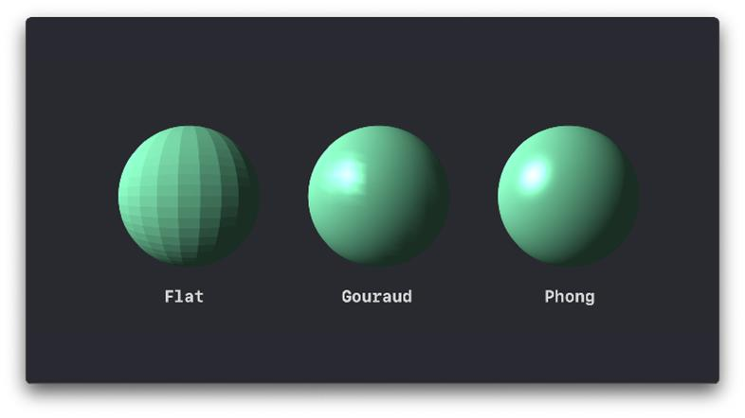
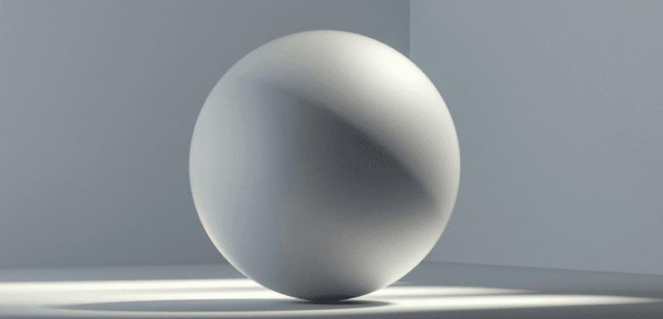
- Light is calculated across vertices and interpolated
- Color changes gradually from light to dark
- No sharp edges between faces
- Object looks continuous and curved

🧠 Simple example
# Source: AI Source: Provided by: [Data Path: Persons Table -> ID Column: 1, Name_En Column: Motasem Essam] -> From: [ChatGPT] on [5/2/2026]
Think of:
- ⚽ A real football (soccer ball) → looks smooth and round
- 🟠 An orange → light fades smoothly across its surface

🎮 Where smooth shading is used
# Source: AI Source: Provided by: [Data Path: Persons Table -> ID Column: 1, Name_En Column: Motasem Essam] -> From: [ChatGPT] on [5/2/2026]
- 🎮 Modern video games
- 🎬 Movies and animation (CGI)
- 🧑‍🎨 3D modeling and rendering software
- 🕶️ Virtual Reality (VR) environments

⚙️ Key features
# Source: AI Source: Provided by: [Data Path: Persons Table -> ID Column: 1, Name_En Column: Motasem Essam] -> From: [ChatGPT] on [5/2/2026]
- 🌗 Smooth transition of light and color
- 🔄 No visible polygon edges
- 🎯 Makes objects look realistic and curved
- 💻 Requires more computation than flat shading

🚀 In short:
# Source: AI Source: Provided by: [Data Path: Persons Table -> ID Column: 1, Name_En Column: Motasem Essam] -> From: [ChatGPT] on [5/2/2026]
Smooth Shading = a shading method where light changes gradually across a surface, making 3D objects look smooth and realistic.

